MAIN GENERAL PAGE
STEEL SIDING & SOFFIT
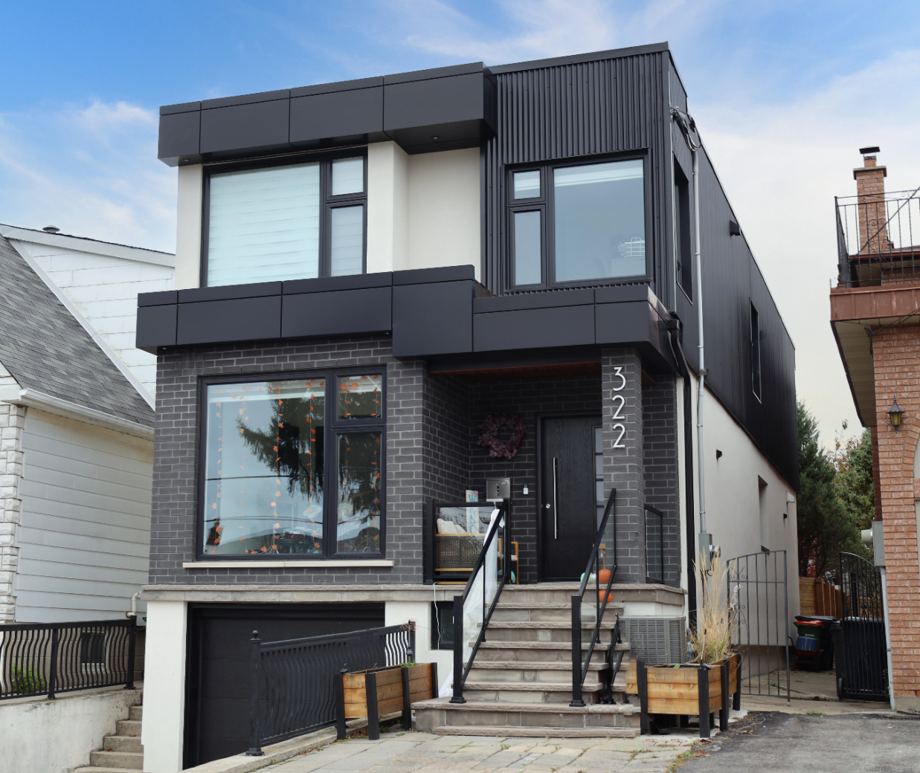
Industrial / Residential / Commercial / Agricultural
Durable, stylish, and cost-effective, metal siding panels offer a modern and long-lasting solution for residential and commercial projects. Made from high-quality steel, these panels provide excellent protection against harsh weather, fire, and pests while enhancing energy efficiency. Their low maintenance requirements and longevity make them a budget-friendly choice over time. With a variety of profiles, finishes, and colors available, metal siding delivers both aesthetic appeal and structural resilience, making it a smart investment for any building.
Curious about the advantages of steel siding? Visit our blog to explore the compelling reasons why this choice stands out for homeowners seeking durability and style.
Speak with an Expert Get personalized advice and expert guidance to achieve your project goals with confidence.

EXPOSED FASTENING (EF) MENU ICON (PREVIEW)

EXPOSED FASTENING (EF) Steel Siding & Soffit
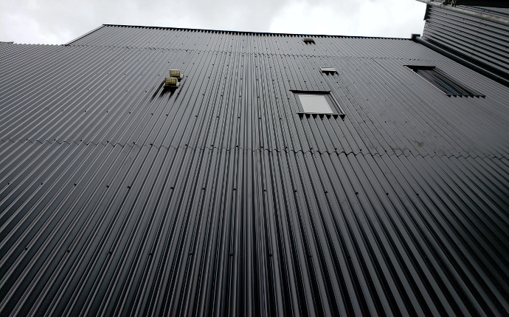
Exposed fastening steel siding systems are known for their strength, simplicity, and cost-efficiency, making them a popular choice across residential, commercial, agricultural and industrial projects.... (Learn More / Expand)

EXPOSED FASTENING (EF) Steel Siding & Soffit (EXPANDED)
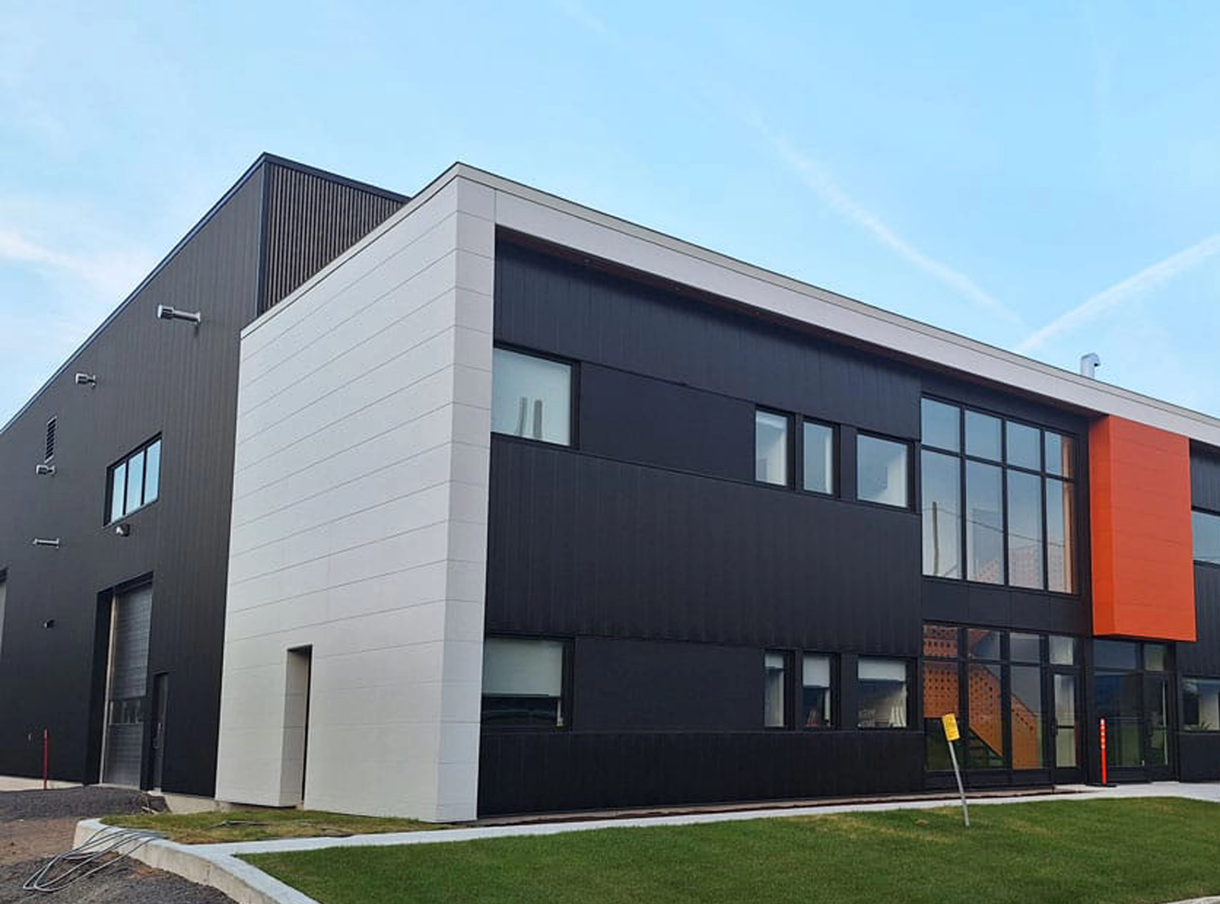
Expanded … Exposed fastening steel siding systems are known for their strength, simplicity, and cost-efficiency, making them a popular choice across residential, commercial, agricultural and industrial projects.
With fasteners intentionally visible, these systems provide a bold, industrial-inspired look while allowing for faster and more economical installation. Their straightforward design doesn’t compromise on durability, offering excellent resistance to weather, impact, and wear. With multiple panel styles and color options available, exposed fastener systems are ideal for projects where performance, value, and visual impact go hand in hand.

1- CORRUGATED MENU ICON (PREVIEW)

CORRUGATED EXPOSED FASTENING (EF) Steel Siding & Soffit 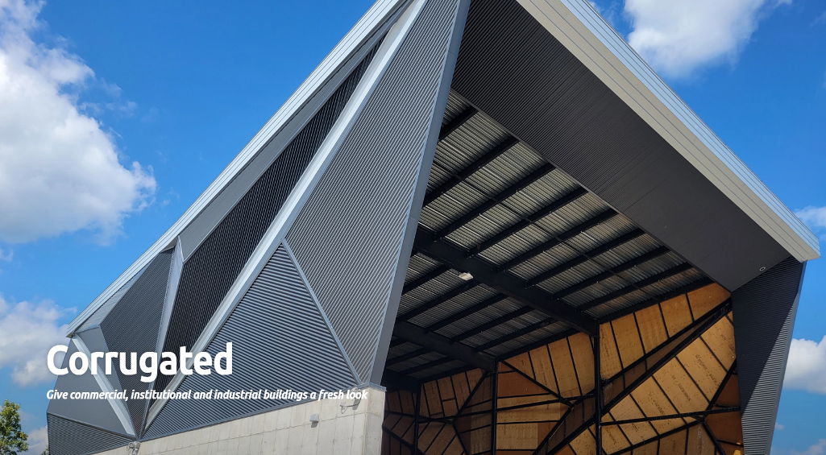
A favorite among architects, the 7/8” Corrugated profile combines timeless design with modern durability. .. (Learn More / Expand)

Profile Options

7/8” Corrugated
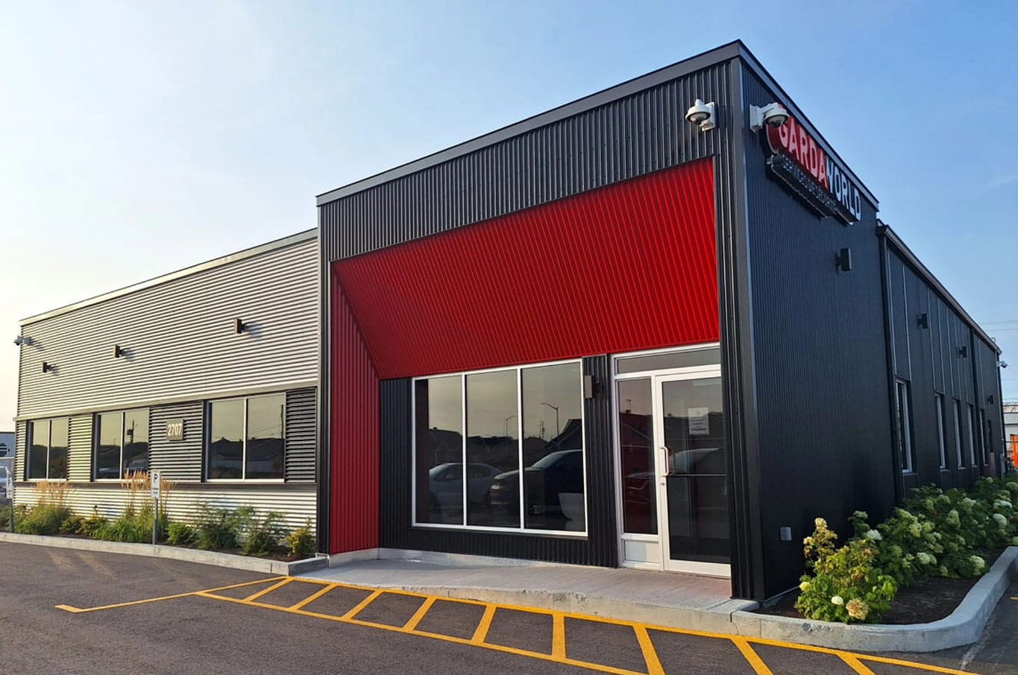
A favorite among architects, the 7/8” Corrugated profile combines timeless design with modern durability.
The 7/8″ Corrugated profile has seen a resurgence in popularity in recent years, whether used horizontally or vertically. Its versatility makes it suitable for both traditional and unique architectural designs, giving commercial, industrial, and institutional buildings a contemporary appearance.
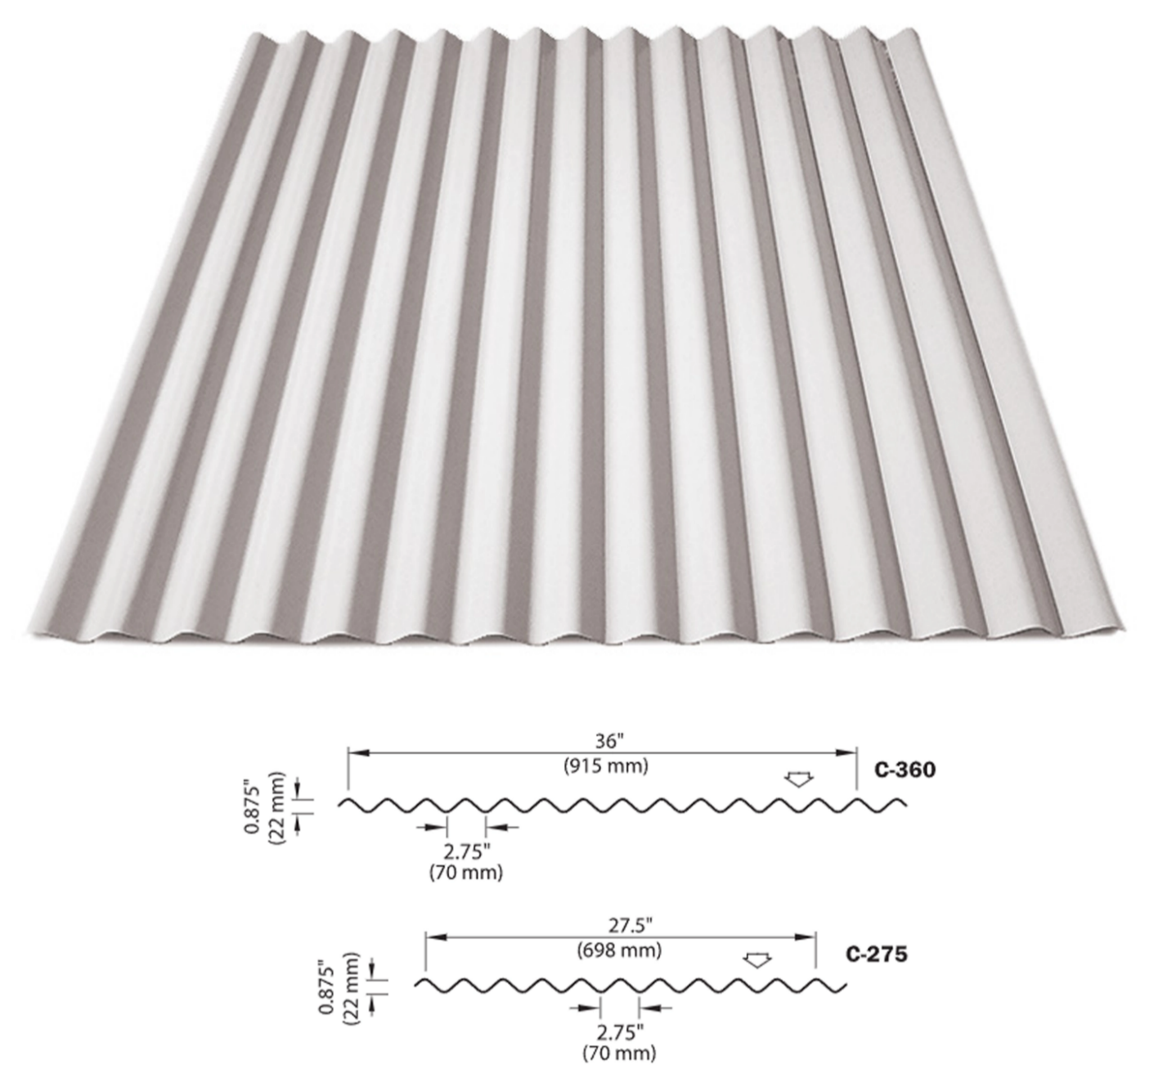
Featuring exposed fasteners and smooth, flowing lines, this profile offers a clean, consistent aesthetic with a naturally organic appeal. Available in a range of widths, thicknesses, and finishes, it provides versatile design possibilities for any project.

These panels come in a wide selection of styles, shades, and textures, allowing for creative freedom without compromising on durability. Whether the goal is visual impact or long-term performance, they offer a dependable cladding option built to meet the demands of modern construction.

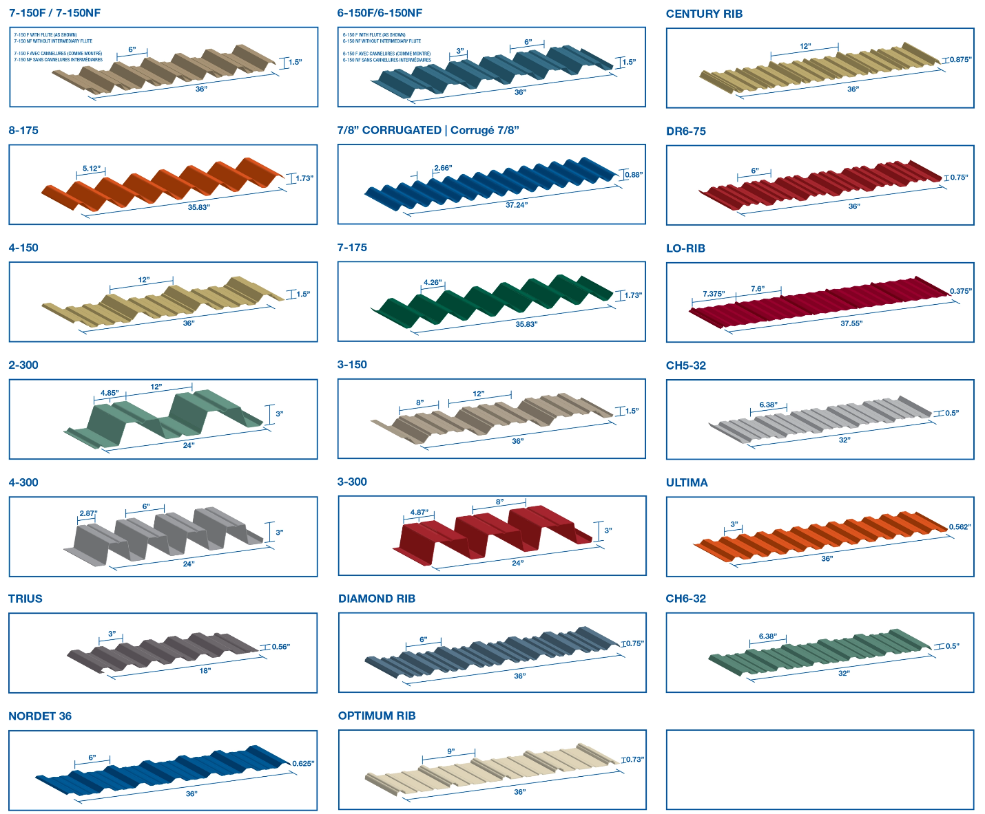

Color chart

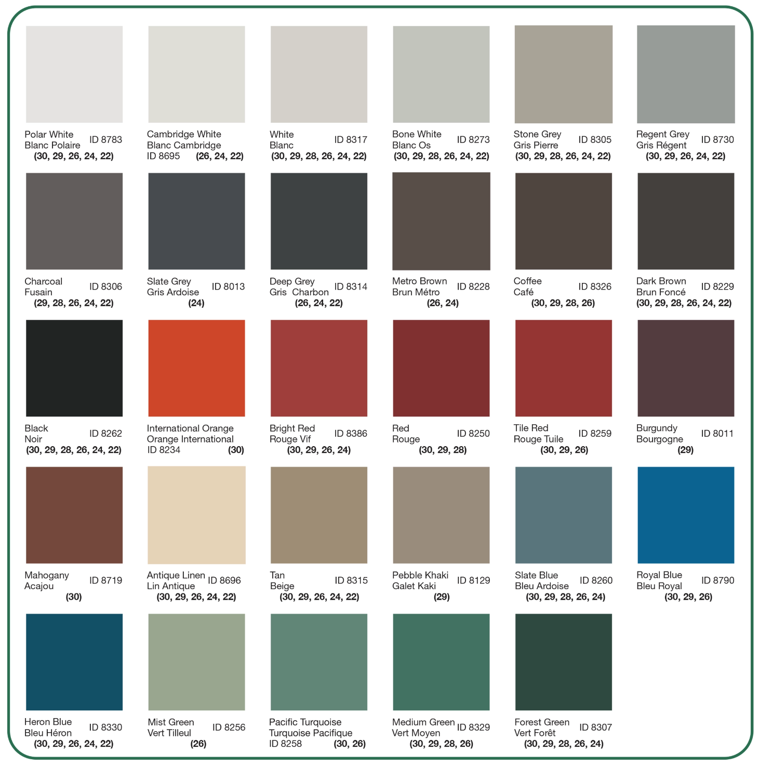

Standard and Custom Flashings
If you need a specific flashing shape, we can fabricate it. Cladcan provides a full range of flashings and trims to complete your commercial or industrial building project. From outside corners to jambs and coping flashings, we’ve got you covered.

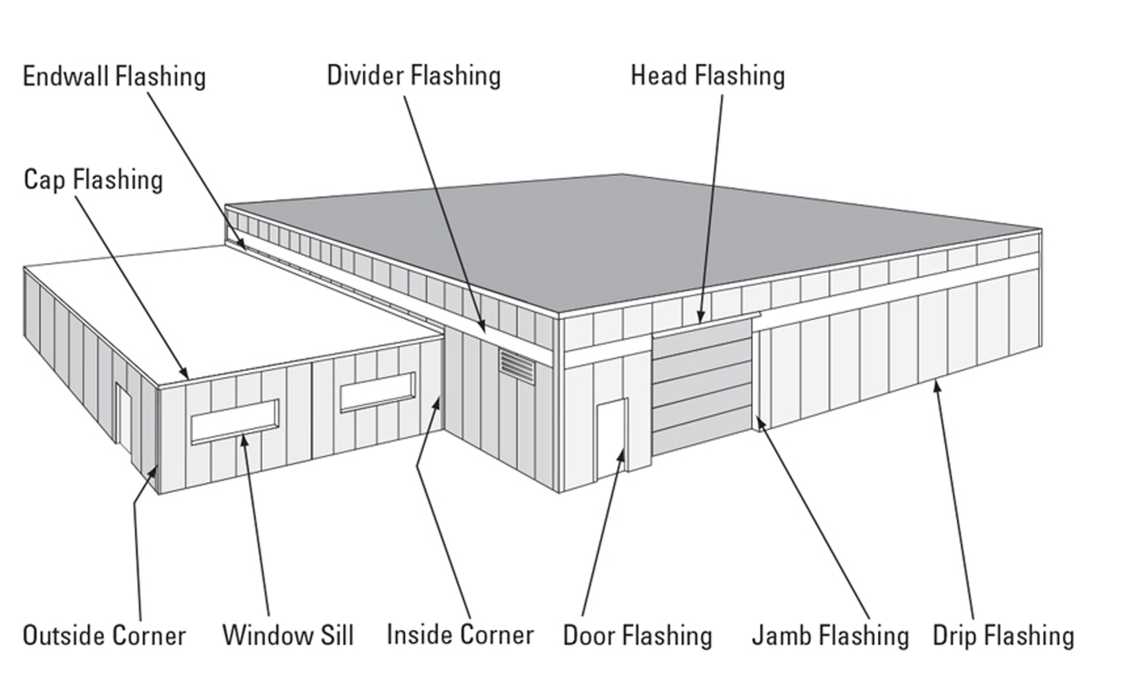

Outside and Inside Corners
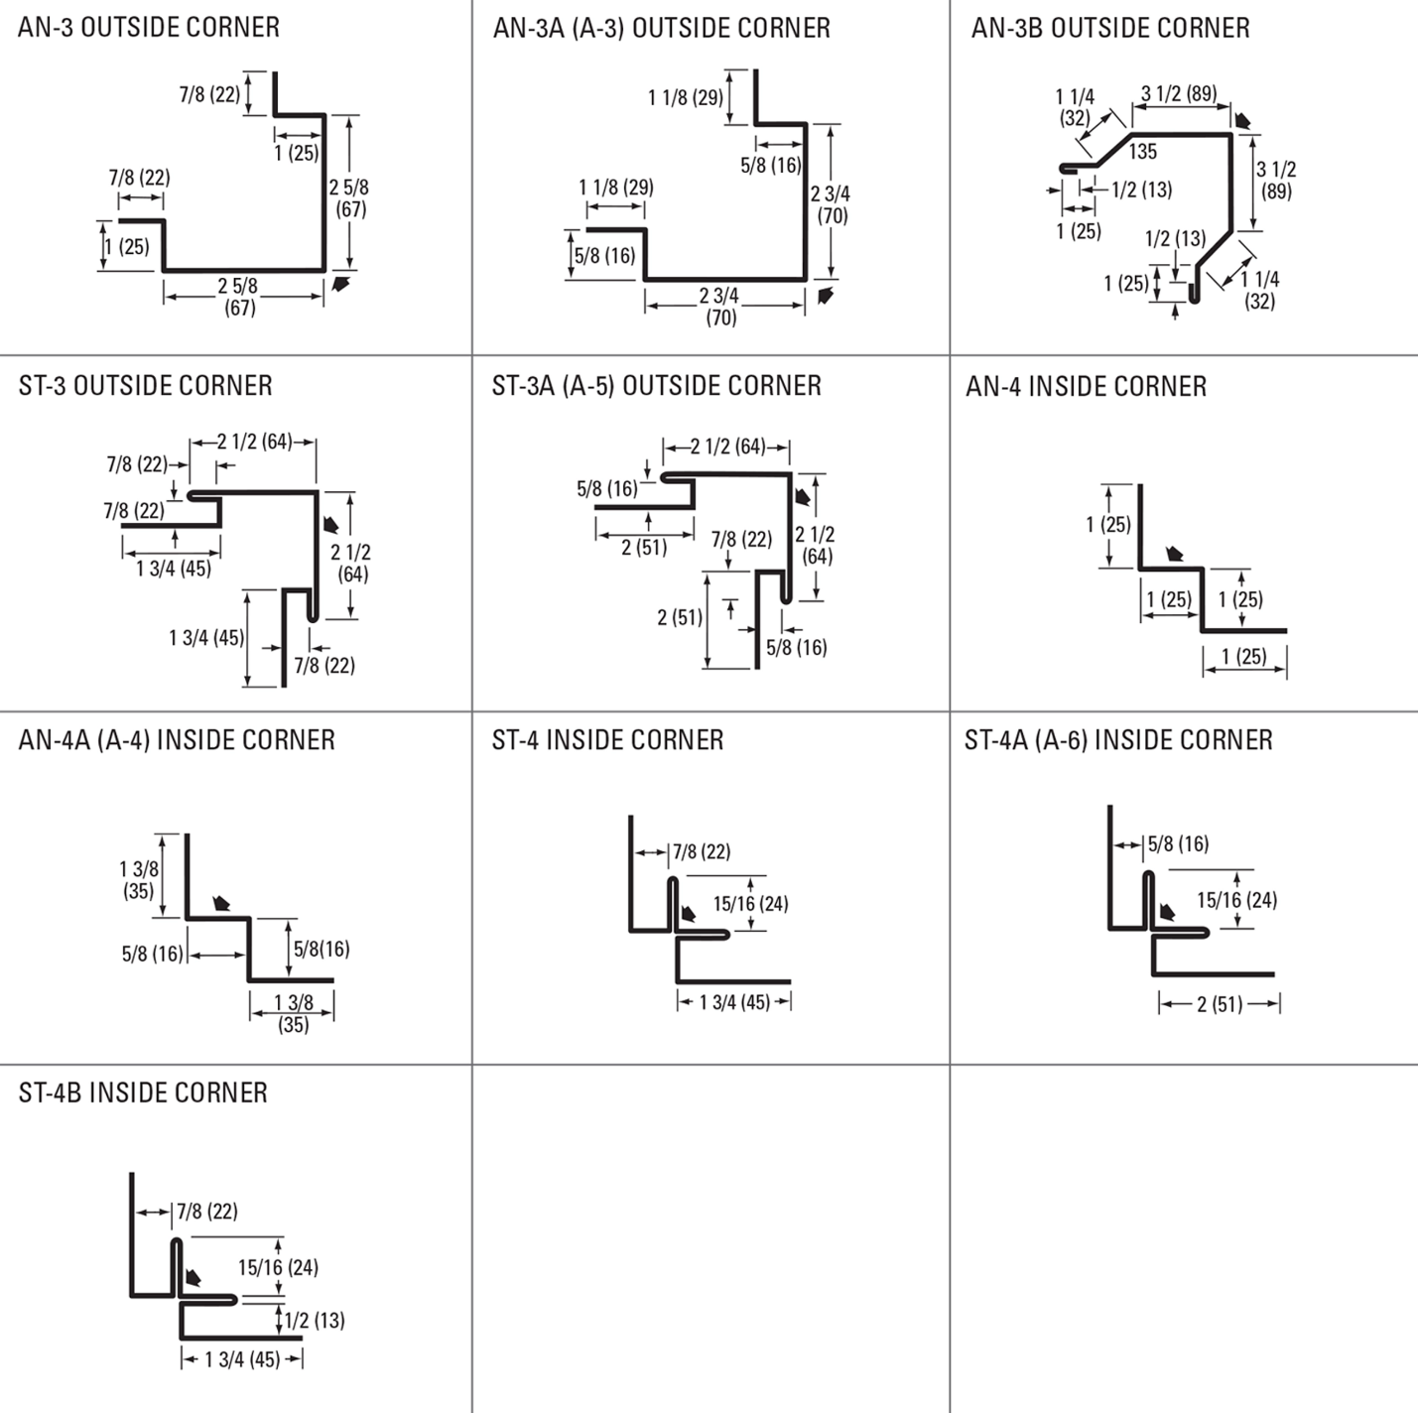

Drip and base Trims, Gable Dividers
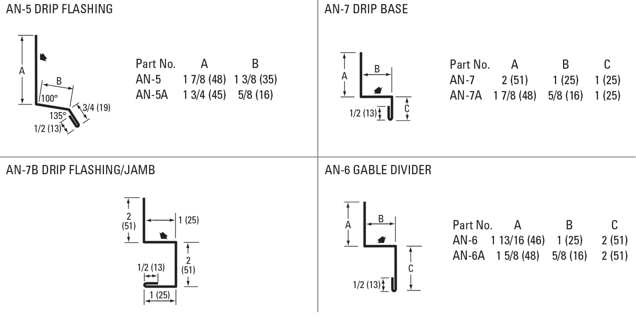
Soffit & Gable Trims, Eaves Starters, Jamb Fkashings
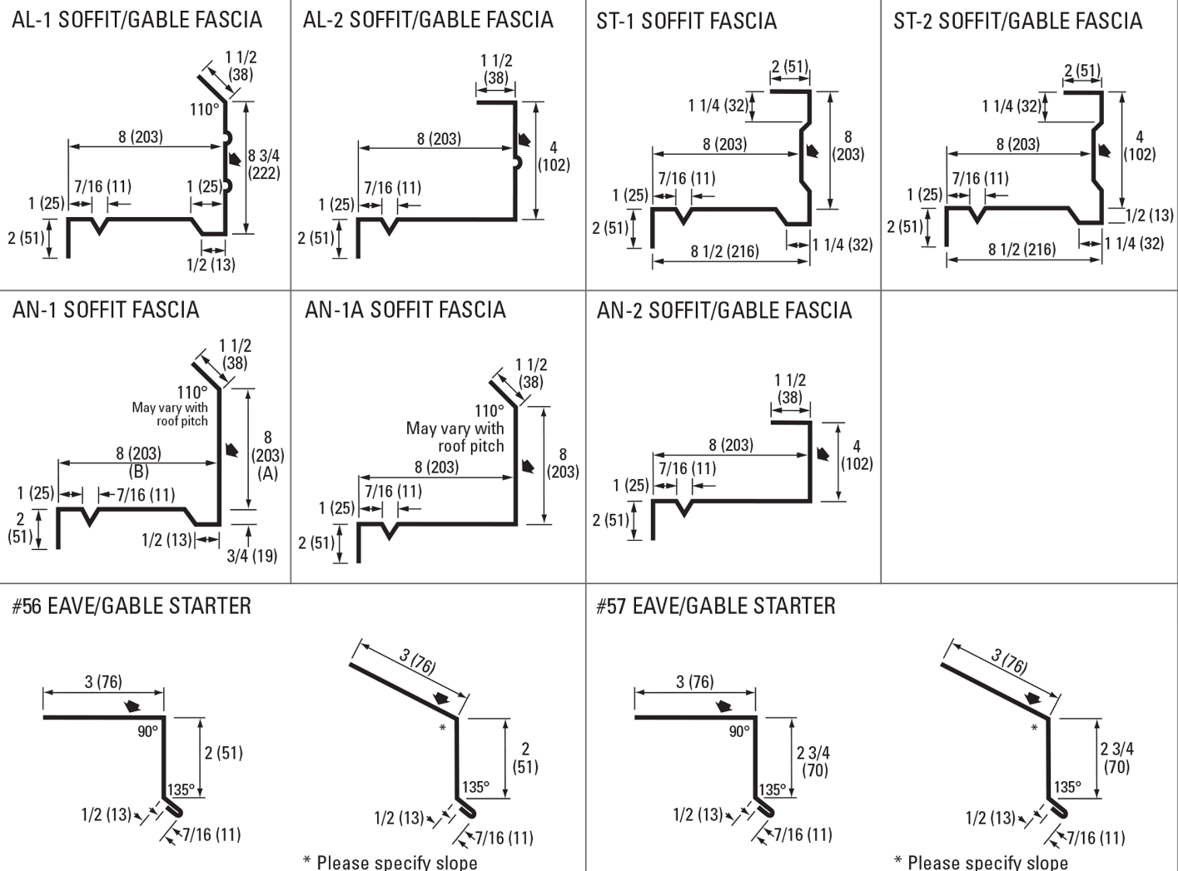
Hip Flashings, Endwalls, J-Trims, Ceiling & Sliding Door Trims
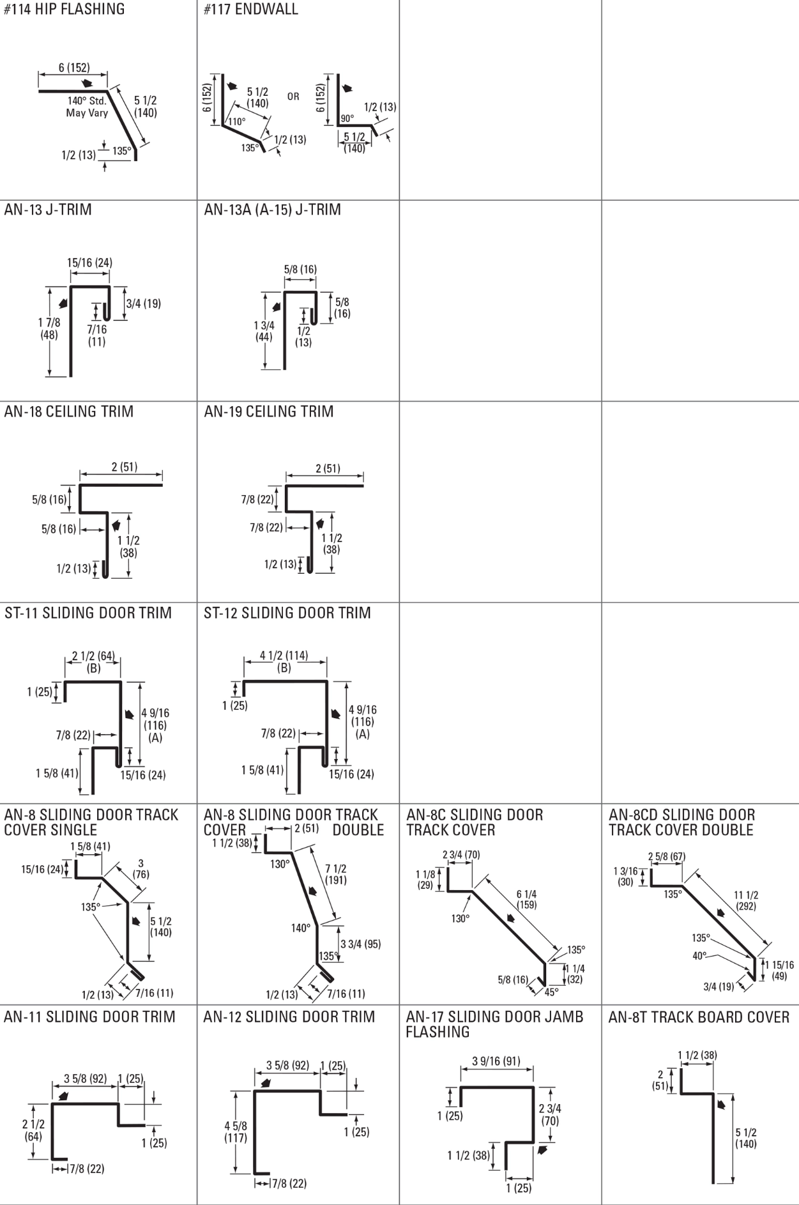

Finishes Perspectra Plus Series™
The Perspectra Plus Series™ represents the next evolution of our Perspectra Series® paint system. Enhanced with advanced Silicone Modified Polyester (SMP) technology and a new resin backbone, it offers superior resistance to chalking, fading, chemical degradation, and scratching.
Designed for maximum durability, the Perspectra Plus Series™ provides exceptional colour fade resistance, improved gloss retention, and increased scratch resistance. With a proven track record, it ensures 40 years of film integrity and 30 years of reliable colour and chalk resistance, making it ideal for roofing and cladding applications across Canada and the continental US.
Available on hot-dip galvanized steel and Galvalume™ (55% Aluminum – 45% Zinc alloy coating), the Perspectra Plus Series™ guarantees long-lasting performance and outstanding protection.

